HD 4203

HD 4203 is a 1.13 M☉, G5 V star1. Based on 60 RV HIRES data obtained between 2000 and 2020, the CL survey reported a GP (HD 4203b) signal with a period of days, a minimum mass of MJup and an eccentricity of as well as a LPGP (HD 4203c) with a period of days, a minimum mass of MJup and an eccentricity of .

In the present study, the CL survey's dataset was used. DPASS and MCMC (1000 walkers and 400000 iterations) were used to fit the data. The properties found for HD 4203b reported in the CL survey were within the error bars associated with the values found in the present analysis. For HD 4203c, the properties found with DPASS were within the error bars reported in the CL survey but the MCMC found much larger error bars with a period between 7500 and 40200 days, a minimum mass between 2.5 and 5.1 MJup and an eccentricity between 0.18 and 0.65. Yet, as the RV curve of HD 4203c only covers a minimum, the period (or *a*) is actually not well constrained.

To explore the range of possible values, the semi-major axis was fixed to different values and the data fitted with DPASS. *a* up to 200 au do not significantly change the rms of the residuals (4 m/s against 3.3 m/s with *a* left free). In this case (referred to as constrained *a*), the minimum mass is 6.4 MJup and the extremely high eccentricity is 0.95. However, changing the stellar offset does not change the possible solutions beyond those found with the constrained semi-major axis.

The fits are shown in Fig 1, and the corner plot in Fig 2, and the results summarized in Table 1.

Conclusion: The properties found in the CL survey for HD 4203c are not confirmed. Additional data are needed to further constrain its orbital properties.

Figure 1: Left: fit of the HD 4203 RV with DPASS. Red - Hir94, green - Hir04. The blue curve shows the best fit. Middle: fit of the HD 4203 RV with DPASS, with the minimum *a* fixed at 200 au. The points are the same as on the left. The blue curve shows the best fit. Right: fit of the HD 4203 RV using MCMC. The black curve shows the best fit. The colorbar corresponds to the log-likelihood of the fits.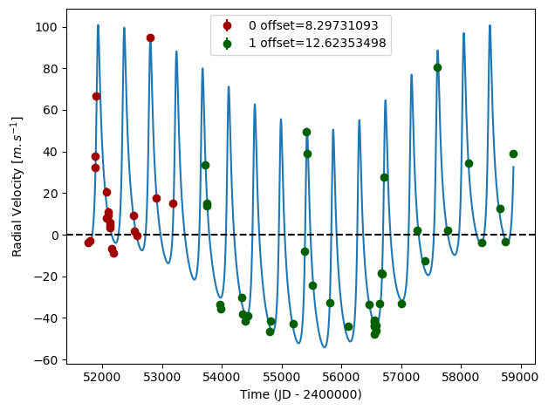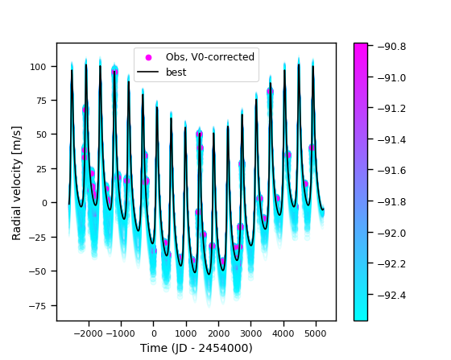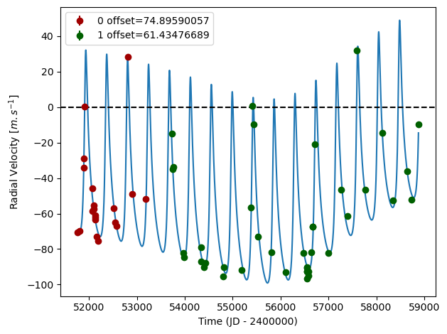

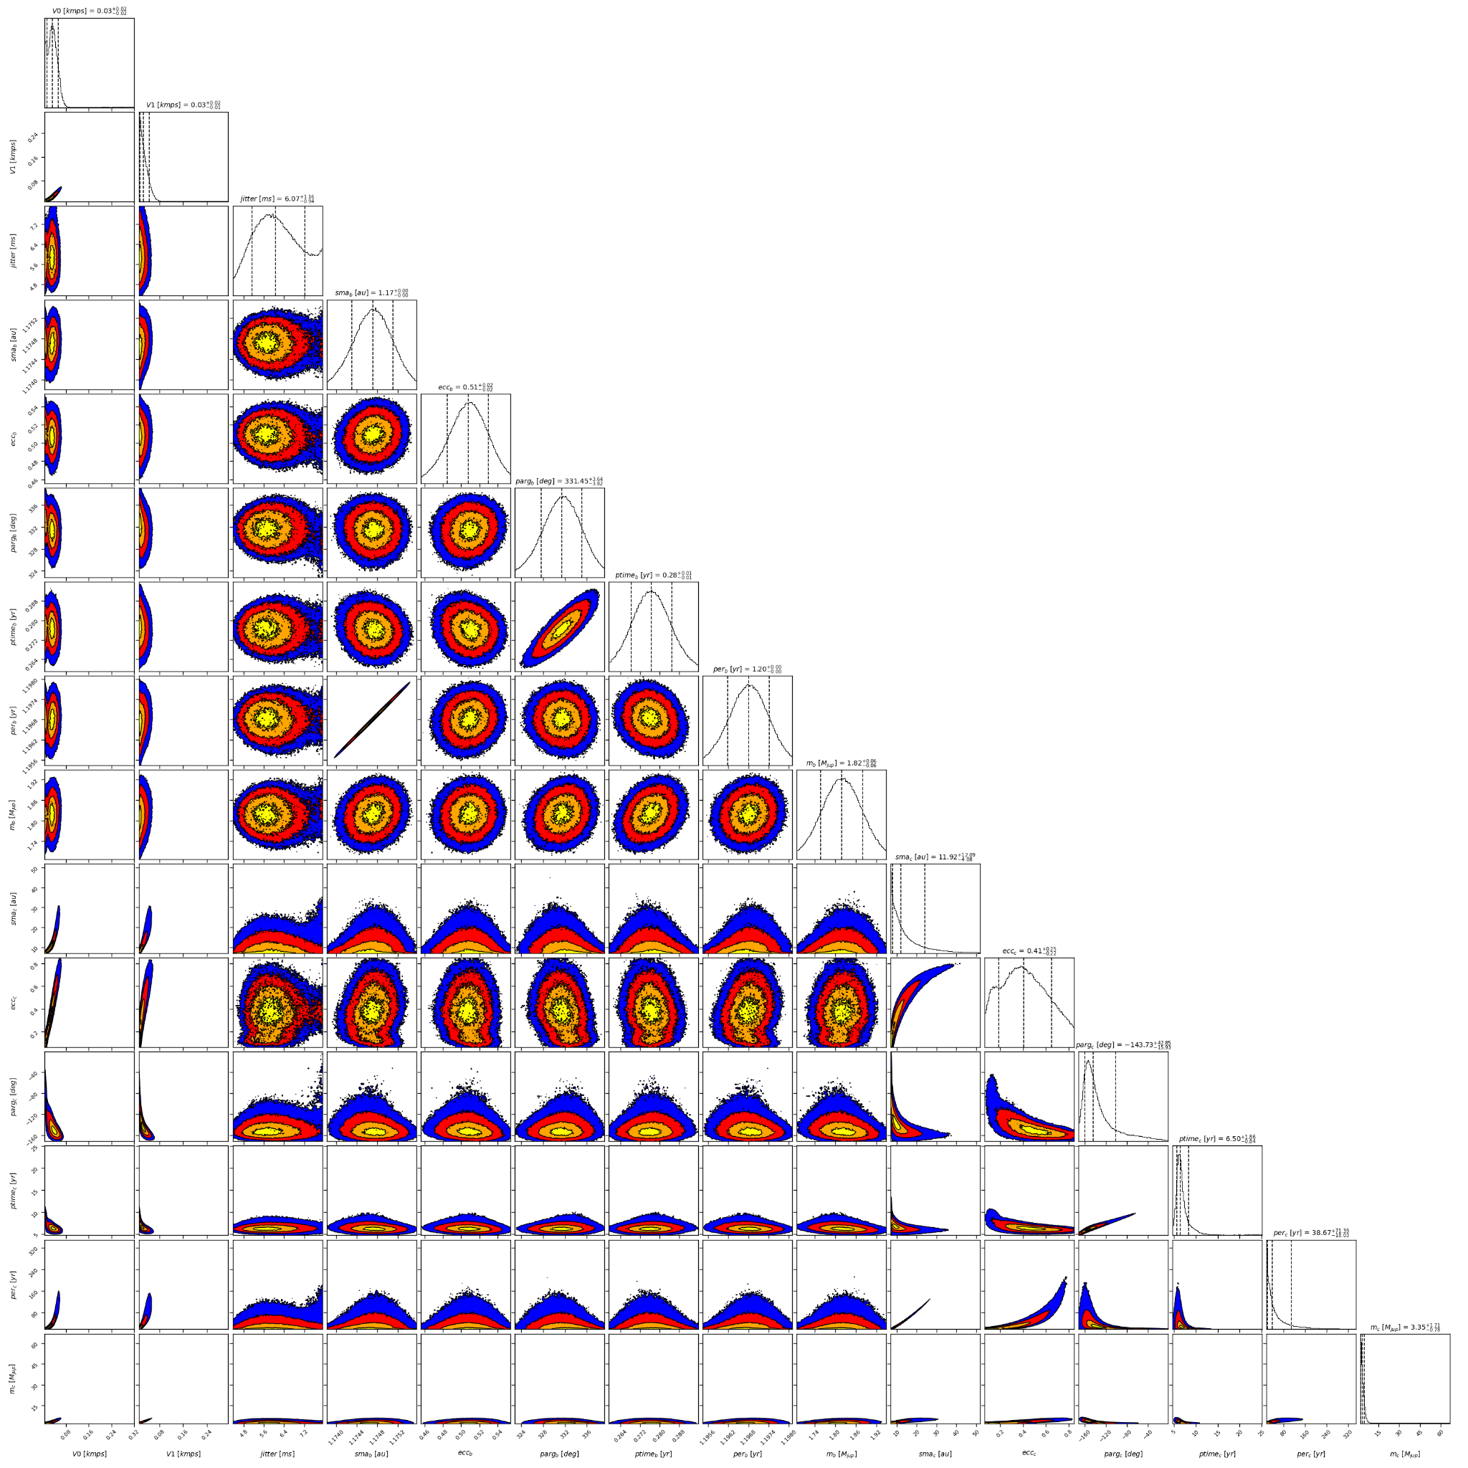

Figure 2: Corner plot of posteriors for the two-planets model MCMC fit of HD 4203 RV data.

| Parameter | Priors | | | Posteriors | | | CL survey |
| --- | --- | --- | --- | --- | --- | --- | --- |
|  | DPASS | | MCMC | DPASS | | MCMC |  |
|  | Free priors | Constrained *a* | Free priors | Free priors | Constrained *a* | Free priors |  |
| *a* (au) | b: [0,300]  c: [0,300] | b: [0,300]  c: up to 200 | b: [0.5,3]  c: [4,300] | b = 1.17  c = 7.2 | b = 1.17  c = 200 | b = 1.17 ± 0.01  c = 7.2 – 24 | b = 1.177+0.021-0.022  c = 7.8+5.4-0.78 |
| Msin(i) (MJup) | b: [0,200]  c: [0,200] | b: [0,200]  c: [0,200] | b: [1,3]  c: [1,100] | b = 1.8  c = 2.5 | b = 1.8  c = 6.4 | b = 1.82 ± 0.06  c = 2.5 – 5.1 | b = 1.821+0.078-0.077  c = 2.68+0.99-0.24 |
| Eccentricity | b: [0,0.95]  c: [0,0.95] | b: [0,0.95]  c: [0,0.95] | b: [0,0.9]  c: [0,0.9] | b = 0.51  c = 0.09 | b = 0.51  c = 0.95 | b = 0.51 ± 0.02  c = 0.18 – 0.65 | b = 0.513+0.013-0.014  c = 0.19+0.29-0.089 |
| Instrumentals offsets (km/s) | [-100,100] | [-100,100] | [-1,1] | Hir94: 0.008  Hir04: 0.013 | Hir94: 0.075  Hir04: 0.061 | Hir94: 0.014 – 0.052  Hir04: 0.014 – 0.045 |  |
| Stellar jitter (m/s) | [0,40] | [0,40] | [0,20] | 4.4 | 5.5 |  |  |
| Argument of periastron (°) | b: [0,360]  c: [0,360] | b: [0,360]  c: [0,360] | b: [0,360]  c: [0,360] | b = 333  c = 256 | b = 329  c = 208 | b = 331 ± 4  c = 200 – 259 |  |
| Phase | b: [0,1]  c: [0,1] | b: [0,1]  c: [0,1] | b: [0,1]  c: [0,1] | b = 0.77  c = 0.57 | b = 0.76  c = 0.06 | b = 0.23 ± 0.01  c = 0.06 – 0.36 |  |

Table 1: HD 4203. Summary of priors and posteriors obtained with DPASS and MCMC, compared to the properties reported by the CL Survey.

References

1. Howard, A. et al. The California Planet Survey. I. Four New Giant Exoplanets. *Astrophys. J.* 721, 1467-1481 (2010).